# **Automated Lead Scraping and Email Outreach System**

# **Lead Automation Command Center - Dashboard:**

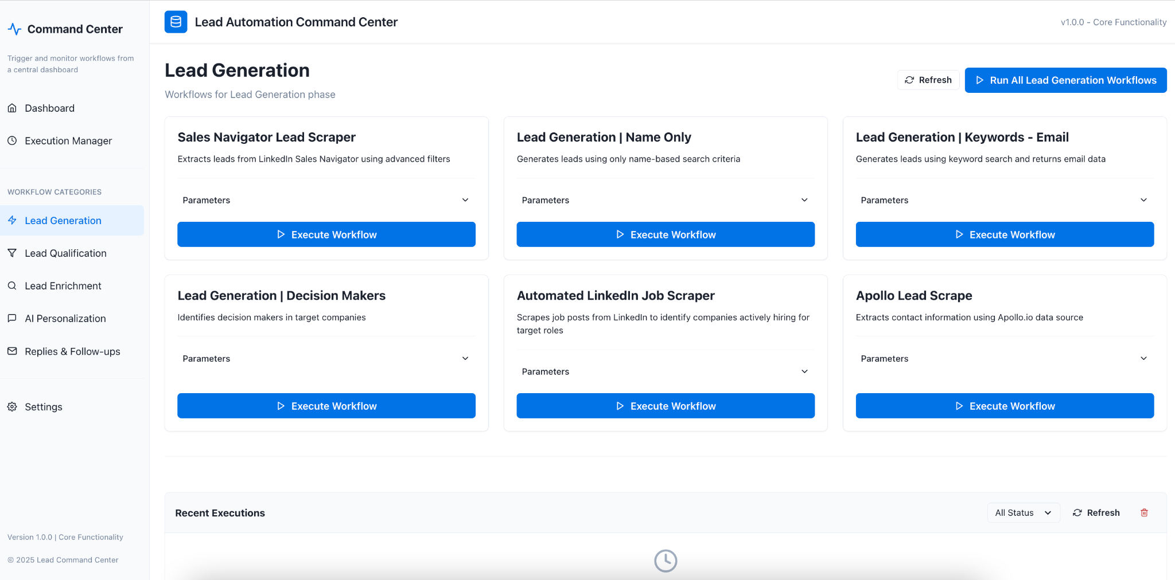

# 

# **Lead Automation Command Center - Execution Manager:**

# **Lead Automation Command Center - Settings:**

# 

# 

# 

# 

# 

# 

# 

# 

# 

# 

# 

# 

# 

# **N8n Workflows:**

# **1 - Lead Generation**

# **Sales | LG | LinkedIn Job Scraper**

# **Sales | LG | Apollo Lead Scraper**

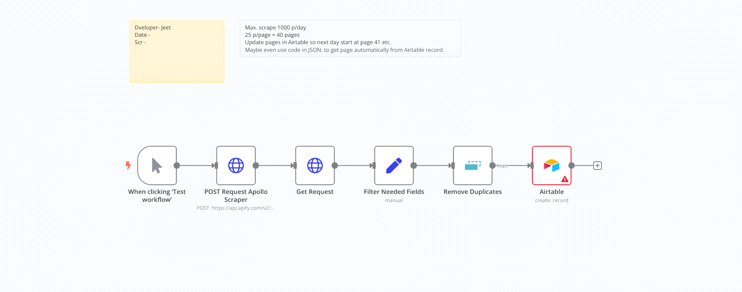

**Sales | LG | Sales Navigator Lead Scraper  
  
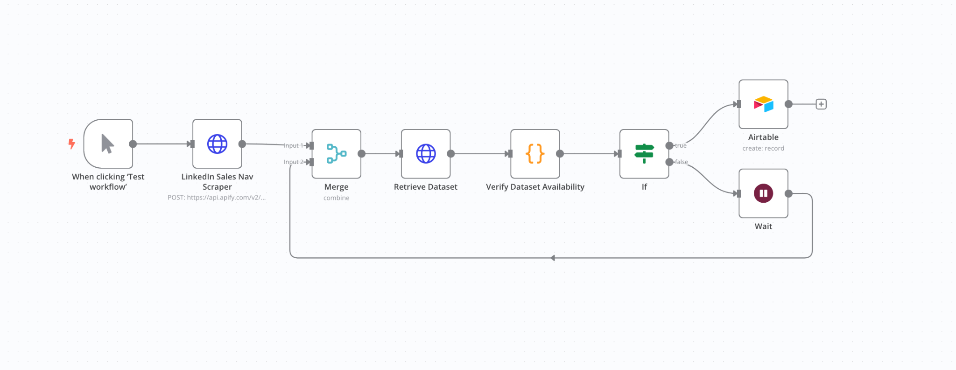**

**Sales | LG | Name Only  
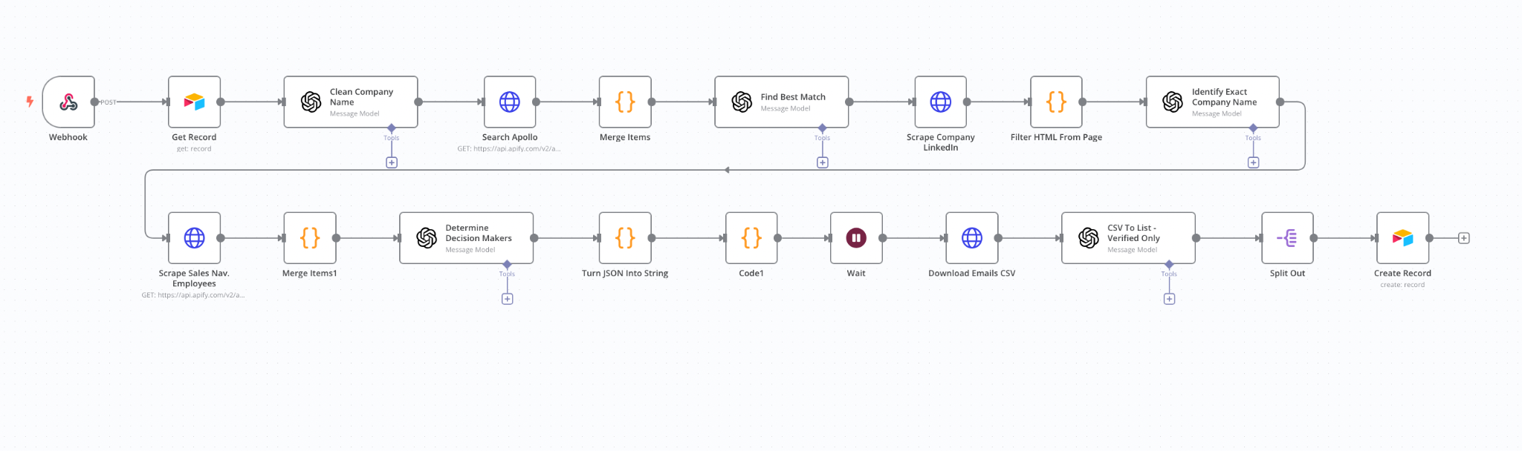  
  
Sales | LG | Decision Makers  
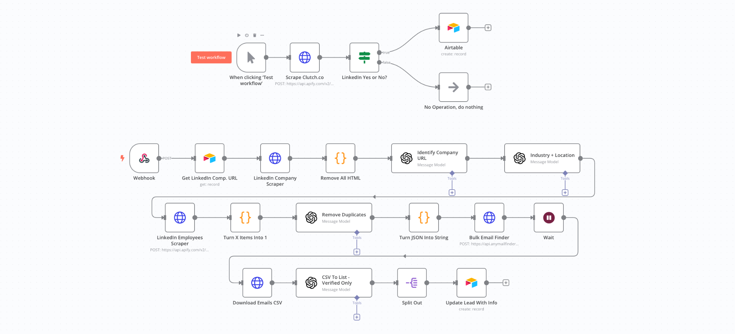**

**Sales | LG | Automation System LinkedIn Job Scraper  
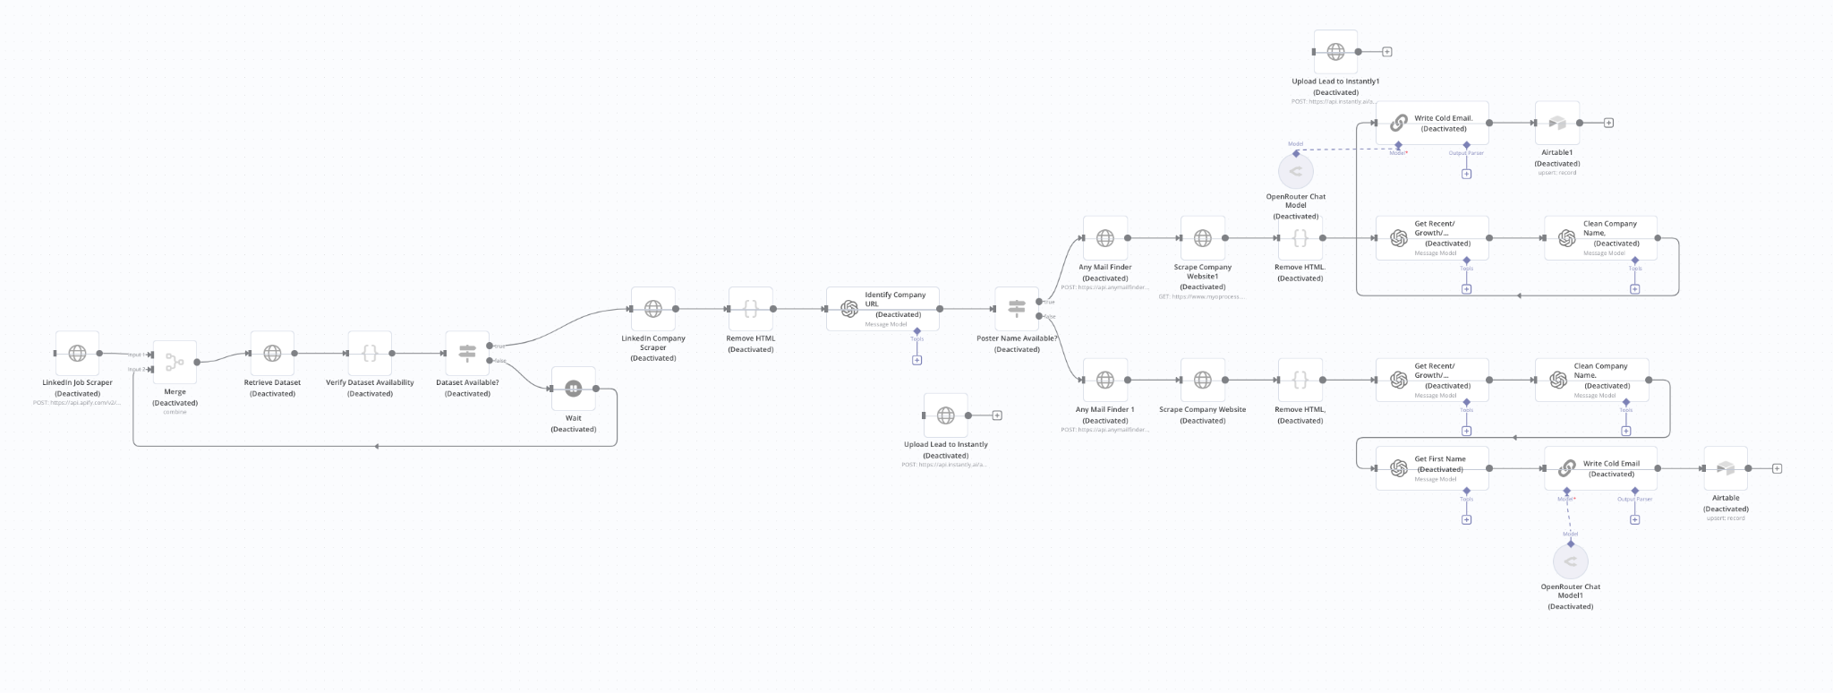**

**2 - Lead Qualification**

**Sales | LQ | Personalization  
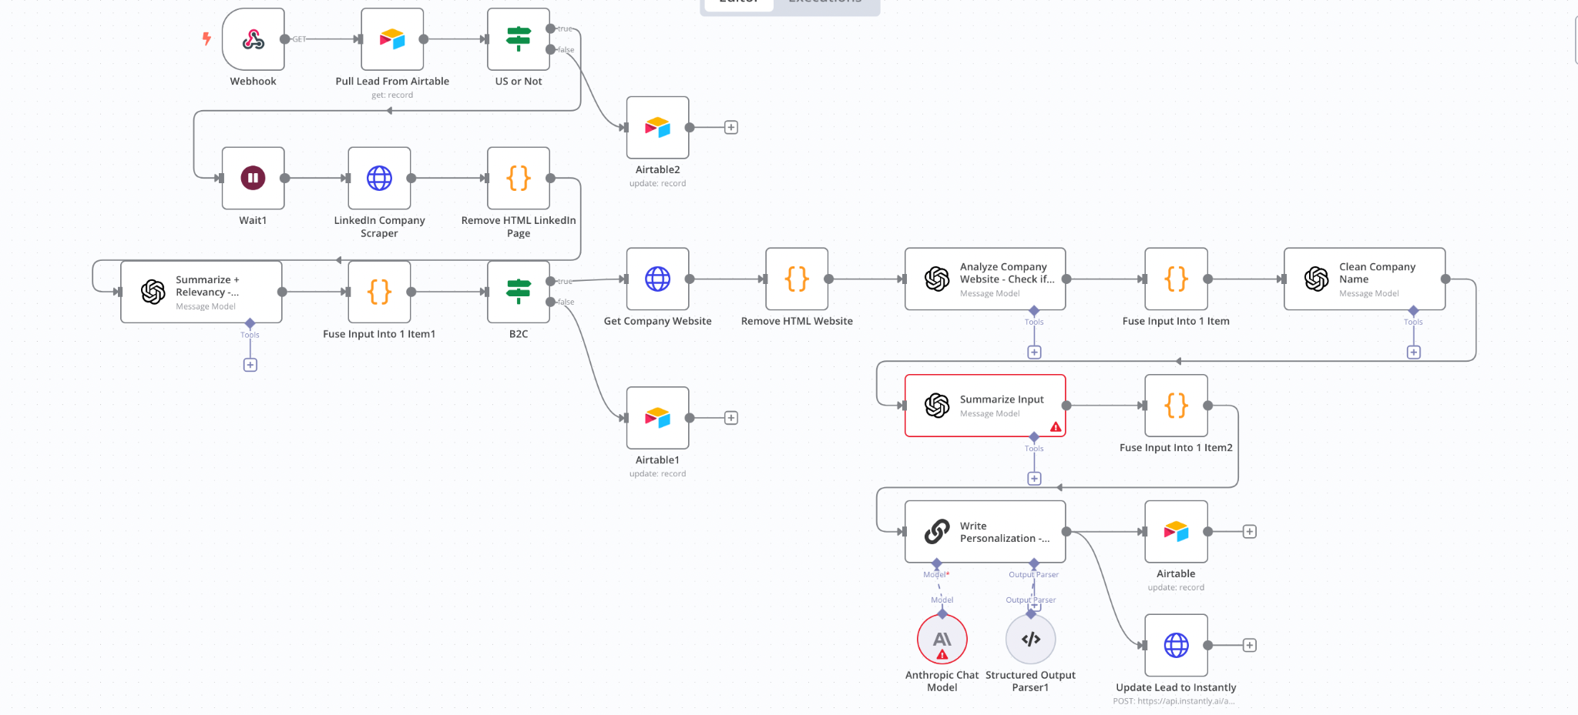**

**Sales | LQ | 3-Step Lead Qualification  
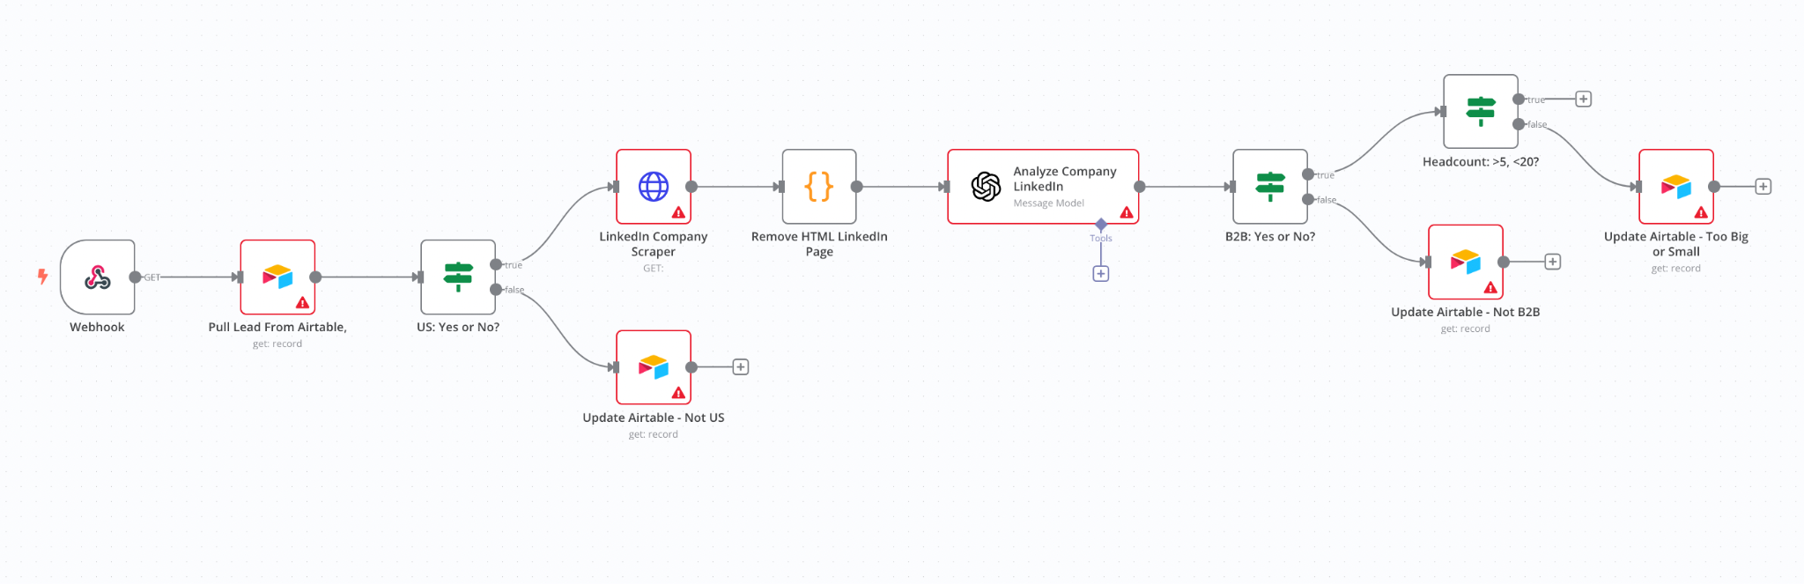**

**3 - Lead Enrichment  
  
Sales | LE | LinkedIn  
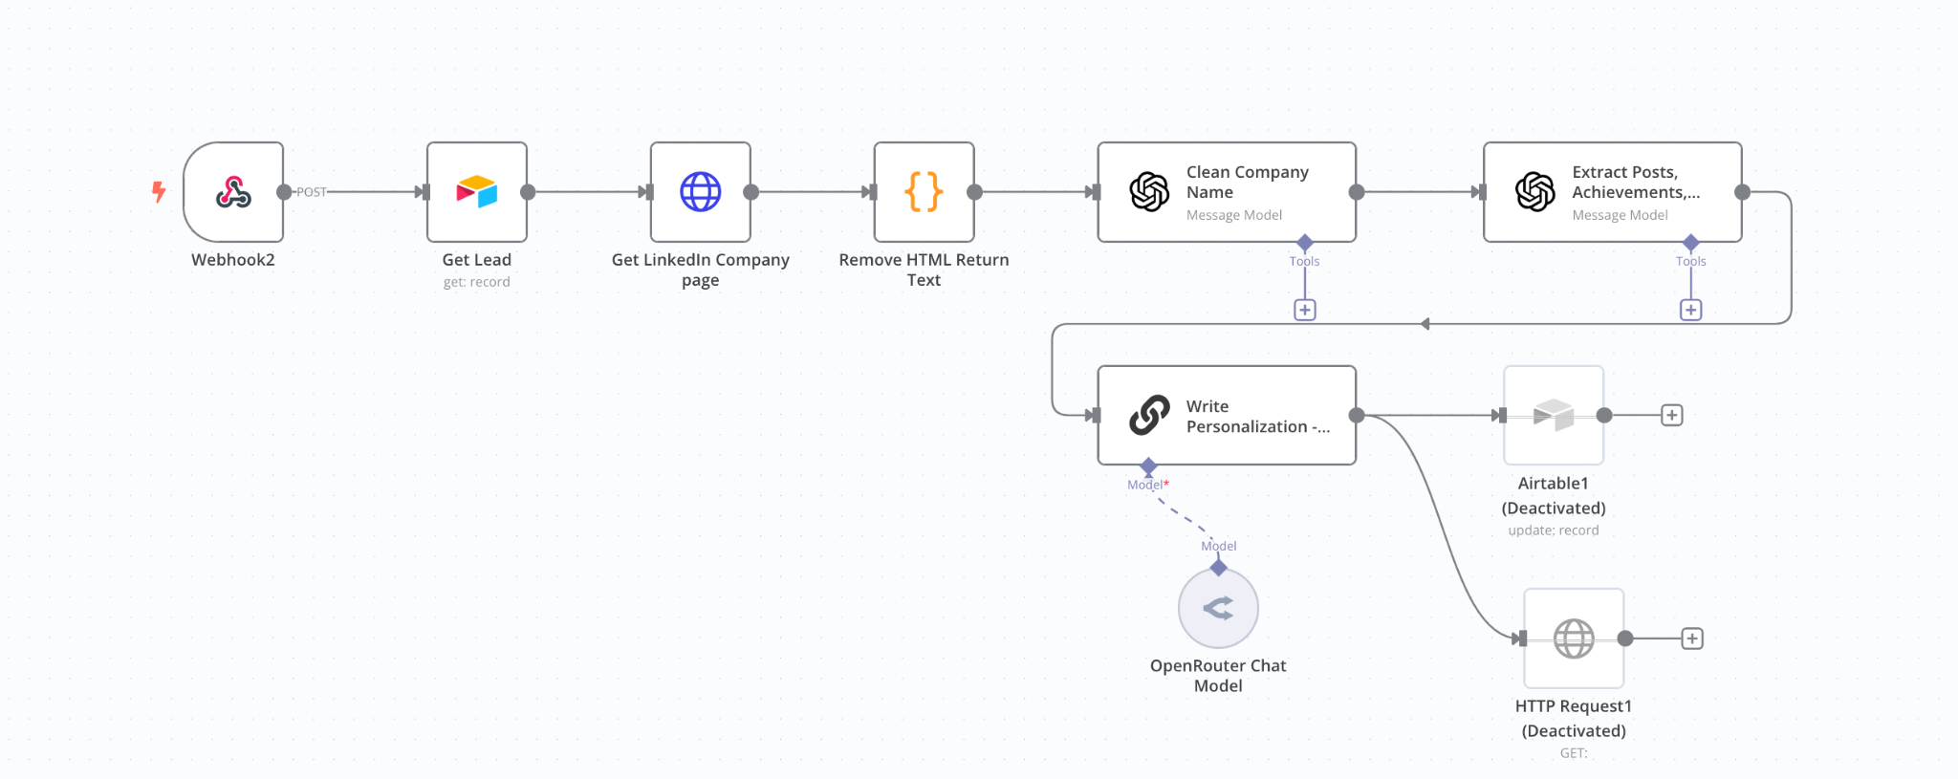**

**Sales | LE | Scrape + Enrich  
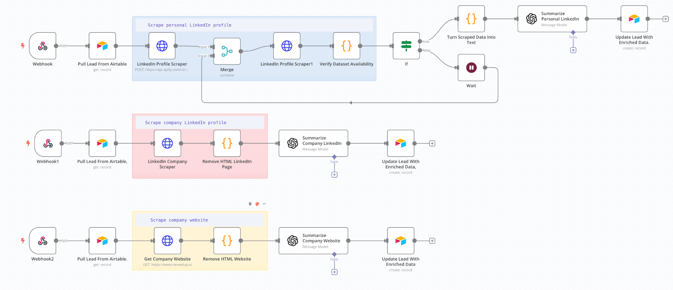**

**Sales | LE | LinkedIn Personalization  
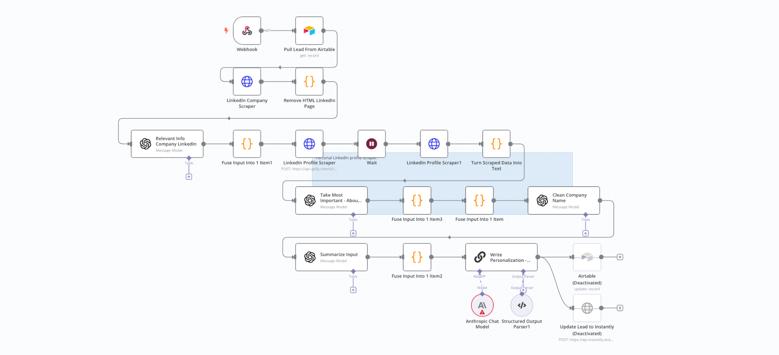  
  
  
Sales | LE | Company Website Smart Crawler  
  
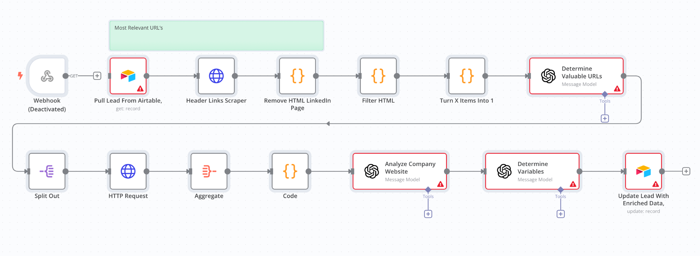  
  
Sales | LE | Enrichment Website Sections  
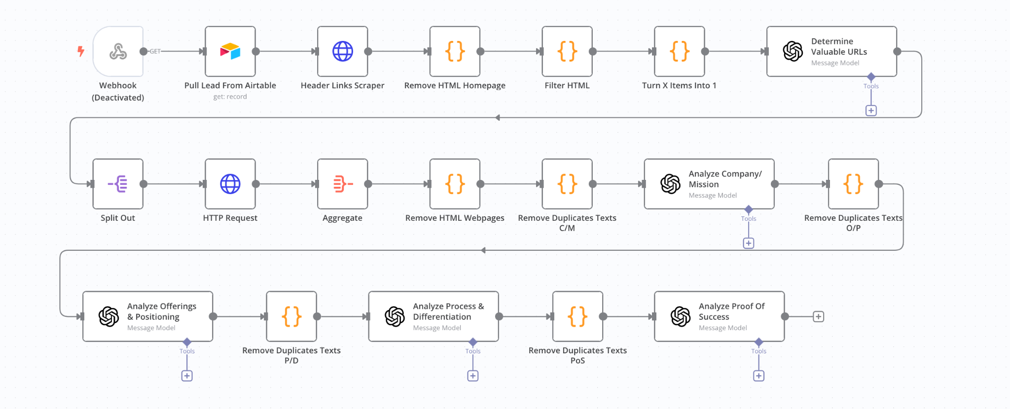**

**4 - AI Personalization**

**Sales | AP | Deep Insights - About Page  
  
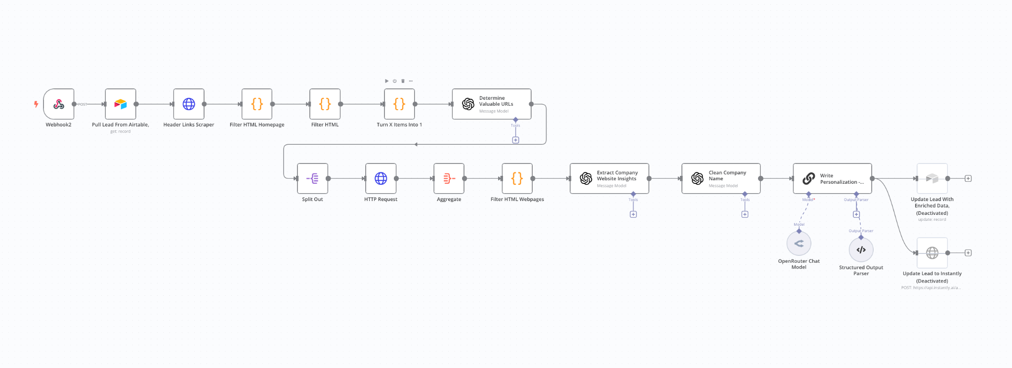  
  
Sales | AP| LinkedIn Post | Personal + Company  
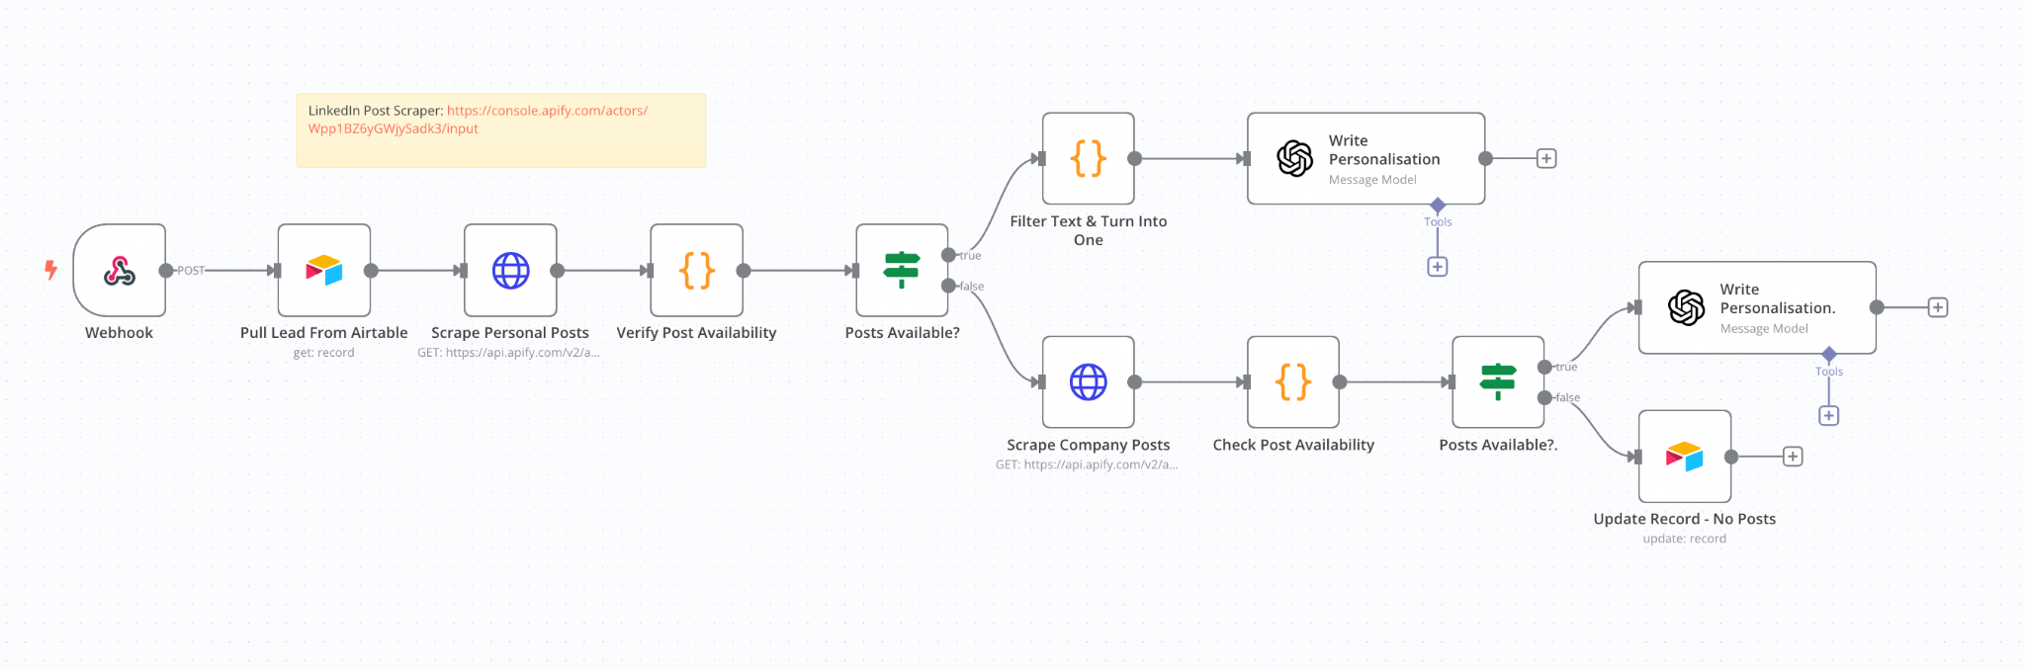**

**Sales | AP | AI Personalization | 3 Snippets  
  
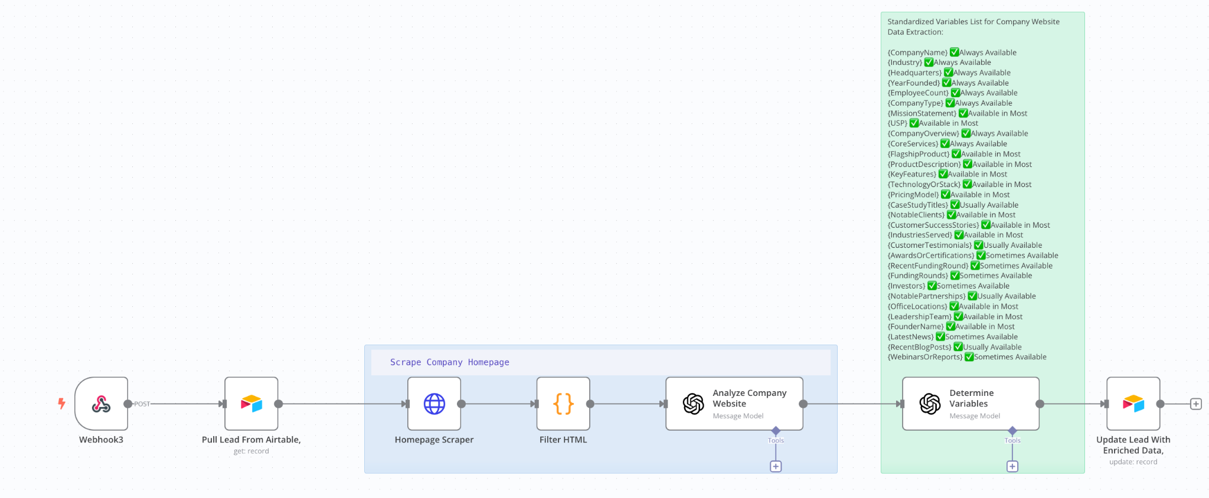**

**Sales | AP | AI Personalization | Departments  
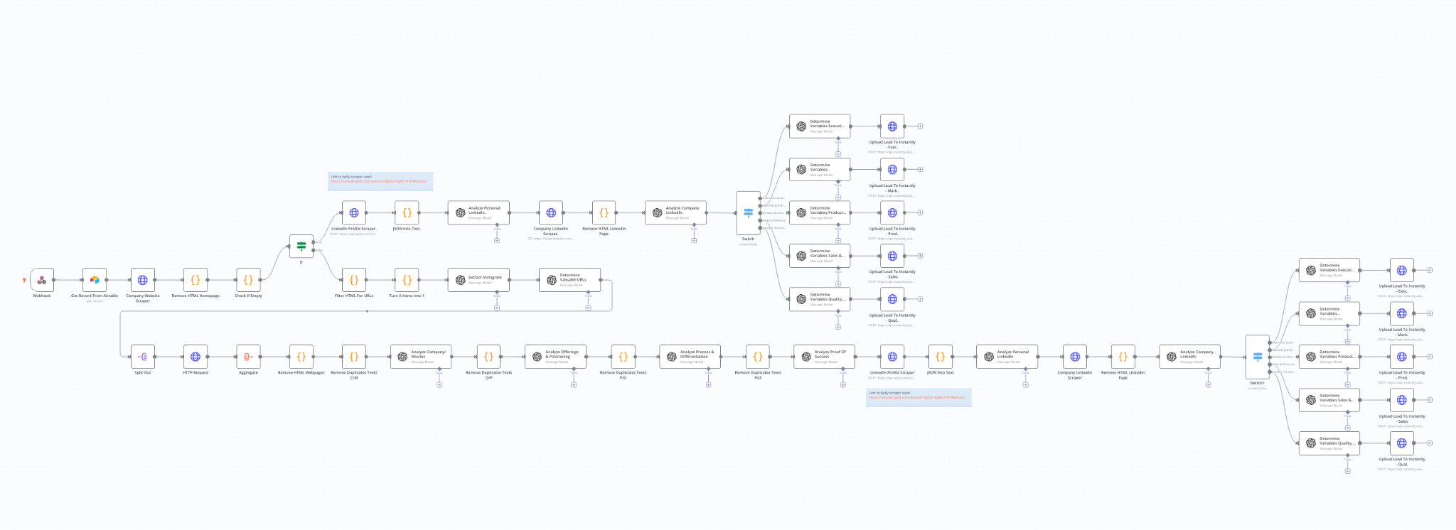  
  
  
5 - Replies & Follow-ups**

**My Sales | R&F | AI Personalization | Departments 35  
